23 January 2026

Sumy State University, Sumy, Ukraine
Ass.Prof. Karpusha Vasyl, Rector
Prof. Dr. Lyulyov Oleksiy, Director of the Academic and Research Institute of Business, Economics and Management

Dear Ass.Prof. Karpusha Vasyl, Prof. Lyulyov Oleksiy

The Association of International Certified Professional Accountants (united forces of American Institute of Certified Public Accountants, USA and Chartered Institute of Management Accountants, UK) highly values established partnership with Sumy State University.

We are pleased to inform you that Sumy State University, Sumy, Ukraine (SumDU) graduates from the Master's Program in Accounting, Finance or Business (see Appendix 1) will be allowed a quicker route to the CGMA Professional Qualification.

The benefits of having an accelerated route to the CGMA Professional Qualification for your graduates are vast, including being benchmarked as one of leading institutions in Ukraine offering a well-developed accounting degree. Moreover, the institution can use the accelerated route as an encouragement for more students to join the accounting major especially those who are keen to embark on a journey towards a management accounting or finance career.

At the same time, the partnership with AICPA & CIMA might enhance the development of the management accounting specialization in the faculty as a part of the CGMA University Program.

Decision has been incorporated into our Exemption Calculator. Qualification may require reassessment against future updates to the CGMA syllabus if the program continues to be offered in later years.
Accredited bachelor's and master's programs have been added to our database, and SumDU graduates can now receive tuition exemptions from a certain level (see Appendix 1).

The proposed entry route does not require from students any form of submission to us, as exemptions are now awarded automatically after completing educational background upon registration.

Sincere gratitude for cooperation!

Nataliia Vovchuk Head of South East Europe
Pawel Rozen Lead Manager -University Partnerships, Europe

Appendix 1

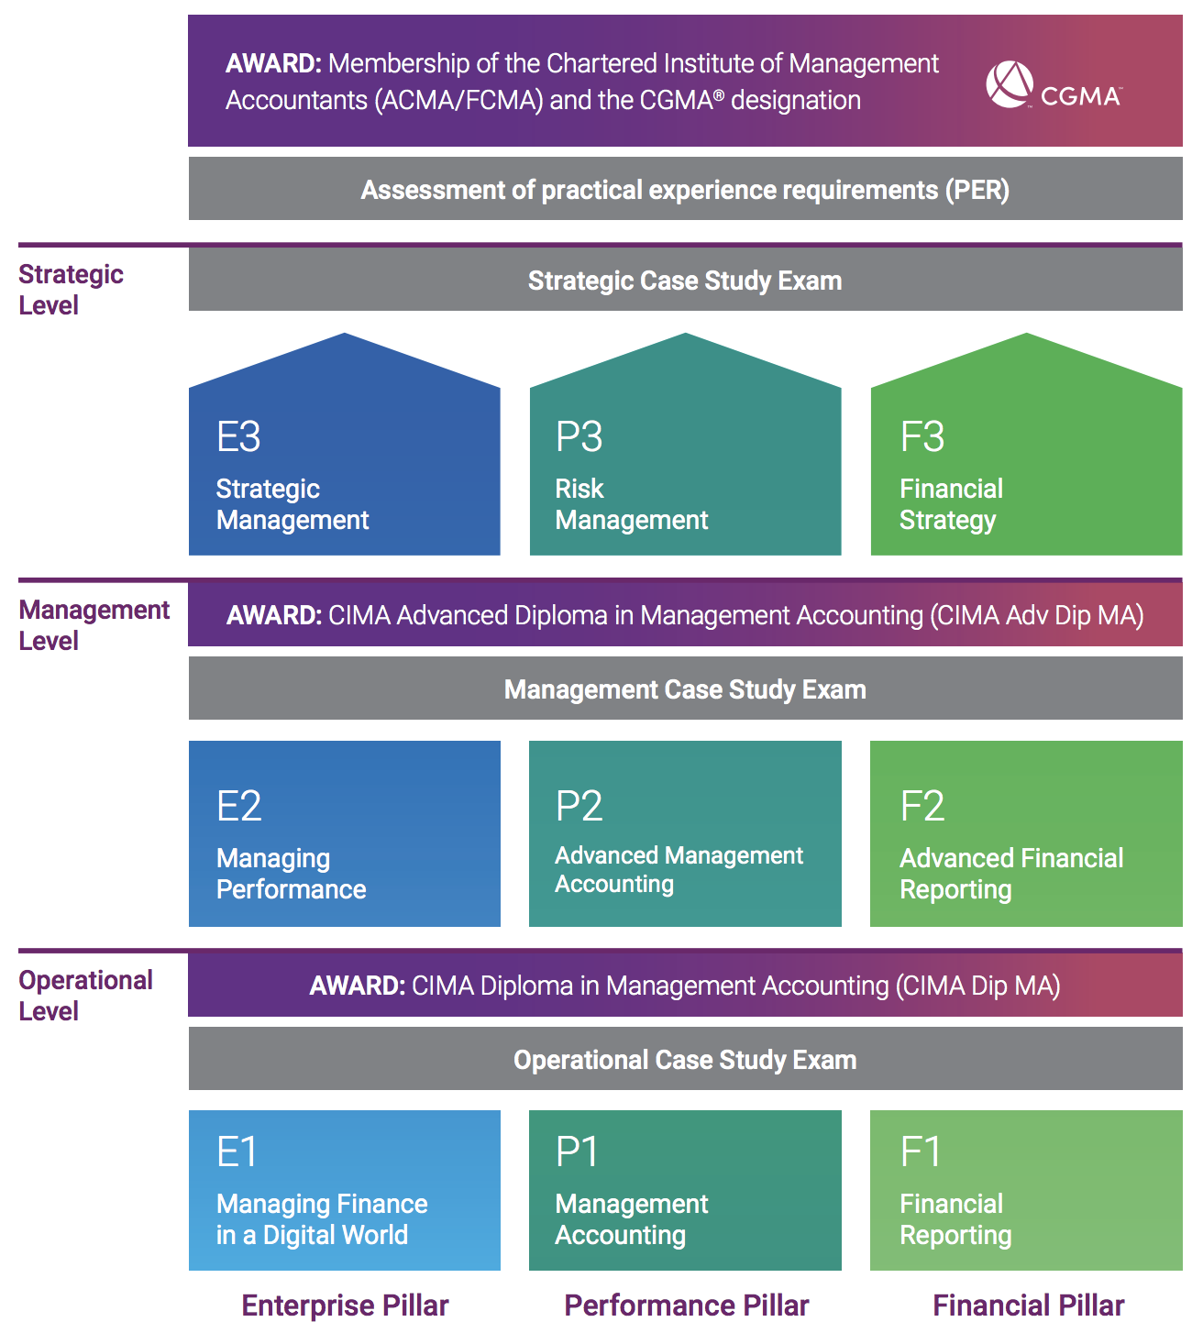

Programme(s) related to Accounting, Finance or Business
Operational level entry | Operational Case Study entry | Management level  entry | Management Case Study  entry
 |  |  | - Master's in Accounting and Taxation

